Problem + Algorithm
Experiment No.: 09
Title: Particle Swarm Optimization (PSO) for Function Optimization
Aim:
Implement Particle Swarm Optimization to maximize a given objective function.
Problem Statement:
Use Particle Swarm Optimization to find the maximum of f(u) = -u² + 5u + 20 over the search interval [-10, 10]. A population of nine particles is initialized at the positions provided in the program. The algorithm updates each particle's velocity and position using its personal best and the swarm's global best.
Algorithm:
- Initialize particle positions and set all velocities to zero.
- Evaluate the fitness of every particle.
- Set each particle's personal best to its initial position and select the global best.
- Update velocity using inertia, cognitive, and social components.
- Update particle positions and keep them within the search boundaries.
- Evaluate new fitness values and update personal best positions.
- Update the global best if a better fitness value is found.
- Repeat for the specified number of iterations and return the best position and fitness.
Program
The following program is based on the supplied Q10_pso notebook. The random seed is set for the reported sample run so that its output is reproducible.
import numpy as np

np.random.seed(42)

def fitness(u):
return -u**2 + 5*u + 20

positions = np.array([
-9.6, -6.0, -2.6, -1.1, 0.6,
2.3, 2.8, 6.3, 10.0
])

n = len(positions)
velocities = np.zeros(n)

# PSO parameters
w = 0.5
c1 = 1.5
c2 = 1.5

# Search boundaries
lower_bound = -10
upper_bound = 10

max_iterations = 10

pbest_positions = positions.copy()
pbest_fitness = fitness(positions)

# Select the particle with the highest fitness
best_index = np.argmax(pbest_fitness)
gbest_position = pbest_positions[best_index]
gbest_fitness = pbest_fitness[best_index]

print("INITIAL POPULATION")
print("-" * 65)
print("Particle | Position | Fitness")
for i in range(n):
print(
f"{i+1:8d} | {positions[i]:8.2f} | "
f"{fitness(positions[i]):8.2f}"
)

print("\nInitial Global Best Position:", gbest_position)
print("Initial Global Best Fitness:", gbest_fitness)

# Perform PSO iterations
for iteration in range(max_iterations):

# Random numbers for each particle
r1 = np.random.rand(n)
r2 = np.random.rand(n)

# Update velocity
velocities = (
w * velocities
+ c1 * r1 * (pbest_positions - positions)
+ c2 * r2 * (gbest_position - positions)
)

# Update position
positions = positions + velocities

# Keep positions within search boundaries
positions = np.clip(positions, lower_bound, upper_bound)

# Calculate new fitness
current_fitness = fitness(positions)

# Update personal best
improved = current_fitness > pbest_fitness
pbest_positions[improved] = positions[improved]
pbest_fitness[improved] = current_fitness[improved]

# Update global best
best_index = np.argmax(pbest_fitness)

if pbest_fitness[best_index] > gbest_fitness:
gbest_position = pbest_positions[best_index]
gbest_fitness = pbest_fitness[best_index]

# Display each iteration
print(f"\nITERATION {iteration + 1}")
print("-" * 65)
print("Particle | Position | Velocity | Fitness")

for i in range(n):
print(
f"{i+1:8d} | {positions[i]:8.4f} | "
f"{velocities[i]:8.4f} | "
f"{fitness(positions[i]):8.4f}"
)

print("Global Best Position:", round(gbest_position, 6))
print("Global Best Fitness:", round(gbest_fitness, 6))

print("\n" + "=" * 45)
print("FINAL RESULT")
print("=" * 45)
print("Best Position =", gbest_position)
print("Maximum Fitness =", gbest_fitness)

# Verify the mathematical maximum
exact_position = 2.5
exact_fitness = fitness(exact_position)

print("\nTHEORETICAL MAXIMUM")
print("Best Position =", exact_position)
print("Maximum Fitness =", exact_fitness)
Output + Analysis
Objective Function: f(u) = -u² + 5u + 20
Search Interval: -10 ≤ u ≤ 10
Initial Population: [-9.6, -6.0, -2.6, -1.1, 0.6, 2.3, 2.8, 6.3, 10.0]
Parameters: inertia weight w = 0.5; cognitive coefficient c₁ = 1.5; social coefficient c₂ = 1.5; maximum iterations = 10.
Program Execution (reproducible sample run):
Result | Value
Initial global-best position | 2.3000
Final best position found | 2.501231
Maximum fitness found | 26.249998
Theoretical maximum position | 2.500000
Theoretical maximum fitness | 26.250000
Execution status | Successfully executed (sample run)
For f(u) = -u² + 5u + 20, the theoretical maximum occurs at u = -b/(2a) = 2.5, with f(2.5) = 26.25. PSO is a stochastic population-based method; the best position found in a finite run may be close to, but not exactly, the theoretical optimum.
Convergence Graph
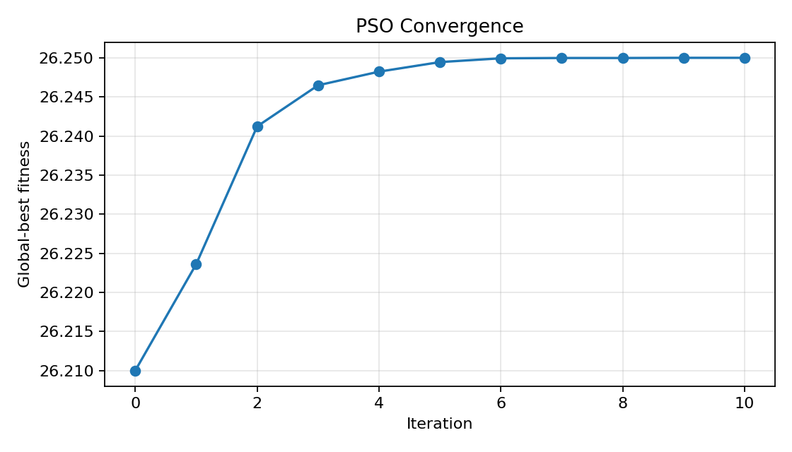
Figure: Global-best fitness across PSO iterations. The global-best value should remain constant or increase as the algorithm retains the best solution found.
X-axis → Iteration
Y-axis → Global-best fitness
Parameter Modification
S. No. | Parameter | Original Value | Modified Value | Observation
1 | Inertia weight (w) | 0.5 | 0.8 | Higher inertia encourages particles to continue moving in their current direction; it can increase exploration.
2 | Cognitive coefficient (c₁) | 1.5 | 2.0 | Places greater emphasis on each particle's personal best.
3 | Social coefficient (c₂) | 1.5 | 2.0 | Places greater emphasis on the swarm's global best.
4 | Maximum iterations | 10 | 50 | More iterations give the swarm additional opportunities to improve, at the cost of more computation.

